**Experiment Number - 1**

**Student Name:** ANIKET KUMAR **UID:** 20BCS5306

**Branch:** CSE **Section/Group:** 20BCS_WM-703 / B

**Semester:** 5th **Date of Performance:** 08th Aug, 2022

**Subject Name:** DAA LAB **Subject Code:** 20CSP-312

**1. Aim/Overview of the practical:** Code and analysis to compute the Greatest Common Divider (GCD) of two numbers.

**2. Task to be done/ Which logistics used:**

Visual Studio Code (IDE).

**3. Algorithms:**

Step1: Start.

Step2: Let A, B be the two numbers.

Step3: A % B = R.

Step4: Let a=B & B=r

Step5: Repeat 2 & 3 until a % b > 0.

Step6: Stop.

**4. Program Code:**

#include <iostream>

using namespace std;

int gcd(int x, int y)

{

if (x == 0)

return y;

if (y == 0)

return x;

if (x == y)

return x;

if (x > y)

return gcd(x-y, x);

return gcd(x, y-x);

if (x < y)

return gcd(x, y-x);

return gcd(x-y, y);

}

int main()

{

int a,b;

cout << "Enter value of a and b :";

cin >> a >> b;

cout<<"GCD of "<<a<<" and "<<b<<" is "<<gcd(a, b);

return 0;

}

**4. Output :**

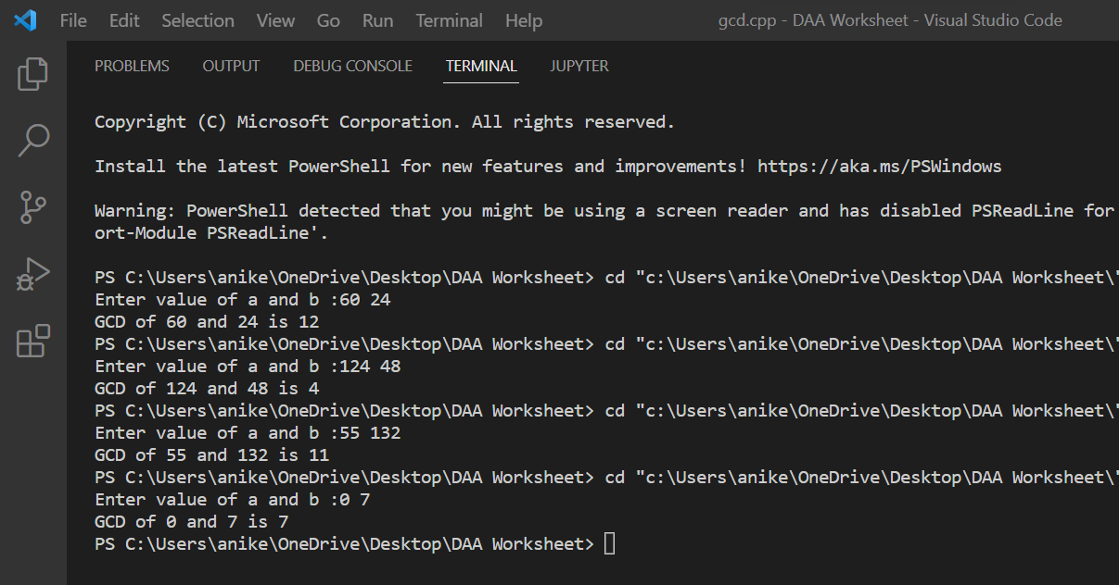

**Learning outcomes (What I have learnt):**

1. I have learnt how to write program in C++.
2. I have learnt about conditionals(if-else, switch-case) and loops(for loop, while loop, do-while loop).
3. I have learnt about arrays and strings.

**Evaluation Grid (To be created as per the SOP and Assessment guidelines by the faculty):**

|  |  |  |  |
| --- | --- | --- | --- |
| Sr. No. | Parameters | Marks Obtained | Maximum Marks |
| 1. |  |  |  |
| 2. |  |  |  |
| 3. |  |  |  |
|  |  |  |  |